MEETING in EMBRUN
From Monday the 04th to Thursday the 07th, April 2005

Days | PROGRAMME PROPOSE
Monday | Anytime  (let us know) | * Arrival  free time (you can ski in les Orres)
Monday | 18H | Meeting at school
Monday | evening | Students with families or at school // teachers at the restaurant
Tuesday | 9H- 10H  10H-12H30 | - Visit of school  - Mise en place des expositions  - Présentation des J.O. (diffusion film)  - Arrival of italian delegation
Tuesday | 13H-14H30 | REPAS au lycée
Tuesday | 14H30- 16H  16H-18H30 | - First meeting  - Visite d’Embrun 
Tuesday | 20H-21H30 | - INTERNATIONAL CUISINE at school
Wednesday   | 9H  9H30-12H | - Meeting at school  - The GRYBB winter Olympic Games  In Les Orres
 | 12H30-13H30 | - Picnic at the ski resort (take your packed lunch)
 | 14H – 16H30 | - Visit of Boscodon + « ferme de l’embrunais » to taste mountain food.
 | 17H-19H | - Rehearsal for the student // Teachers work on the news papers
 | Evening | - Restaurant for teachers (you are invited).  Students at school or in families
Thursday | 8H30  9H-12H | - Meeting at school  - Visit of Briançon.  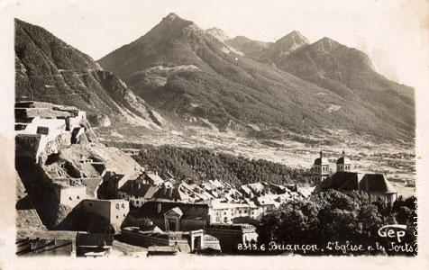
 | 13H-14H30 | - Cheese tasting in Guillestre + picnic  
 | 15H-17H  15H-18H | - Teachers meeting: planning..  - Last rehearsal for the students. 
 | 19H30-20H30 | - Dinner at school for everybody
 | Evening |   - Traditionnal dances: demonstration from a folk group  - Students performance : poems, dances, results of the mascots competition and the GRYBB Olympic Games.  - Let’s dance! Disco for students
Friday |  | - Free Time  - Departures  See you soon  We can’t host in our school on friday evening.

* You can arrive on Sunday evening if you want Just let us know.
The students will stay in families or at school.
The boys who sleep at the school, will have a French students as tutor, breakfast will be from 8H to 8H30; dinner will be at 19H30. The packed lunches will be provided by the school. We’ll try to arrange some activities after the dinner.
The girls (and perhaps some boys if we manage) will live with of our student’s families. Still note that our students are mostly boys, so let us know if you feel there is some problem with your girls staying with a male students even if it’s with his family. Impossible on Friday evening.

