

G.R.Y.B.B.
Comenius 1.3
School Development Project

2004 – 2005

Science, Technology,
Cultural exchanges and Sport



European Commission

Czech Republic – France – Holland – Hungary – Italy – Spain

con il patrocinio Torino Organising Committee XX Olympic Winter Games

G.R.Y.B.B. – The Yellow Ring

Science, Technology
Sport

 | LP Alpes et Durance  Embrun |  |  | 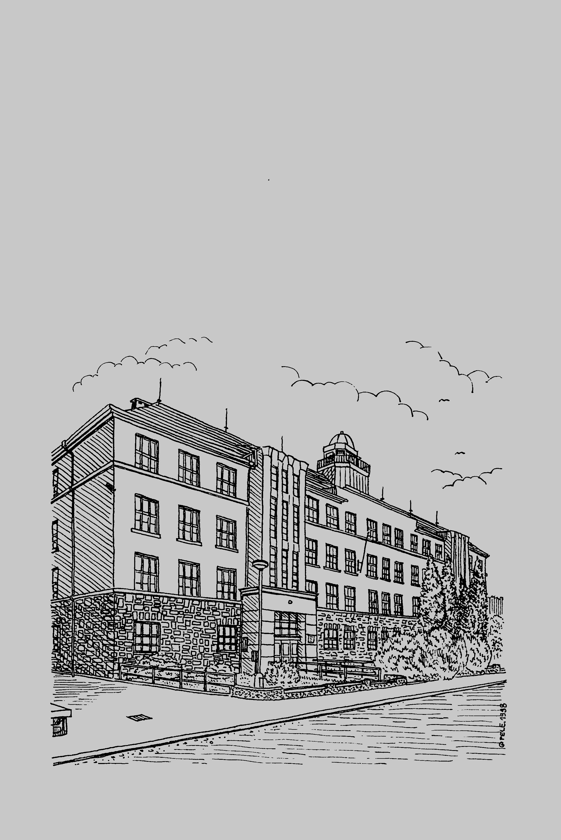 | Hoorn
 | 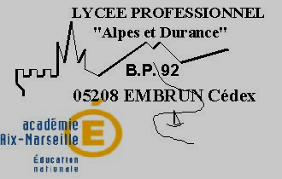 | IISS Des Ambrois  Oulx | 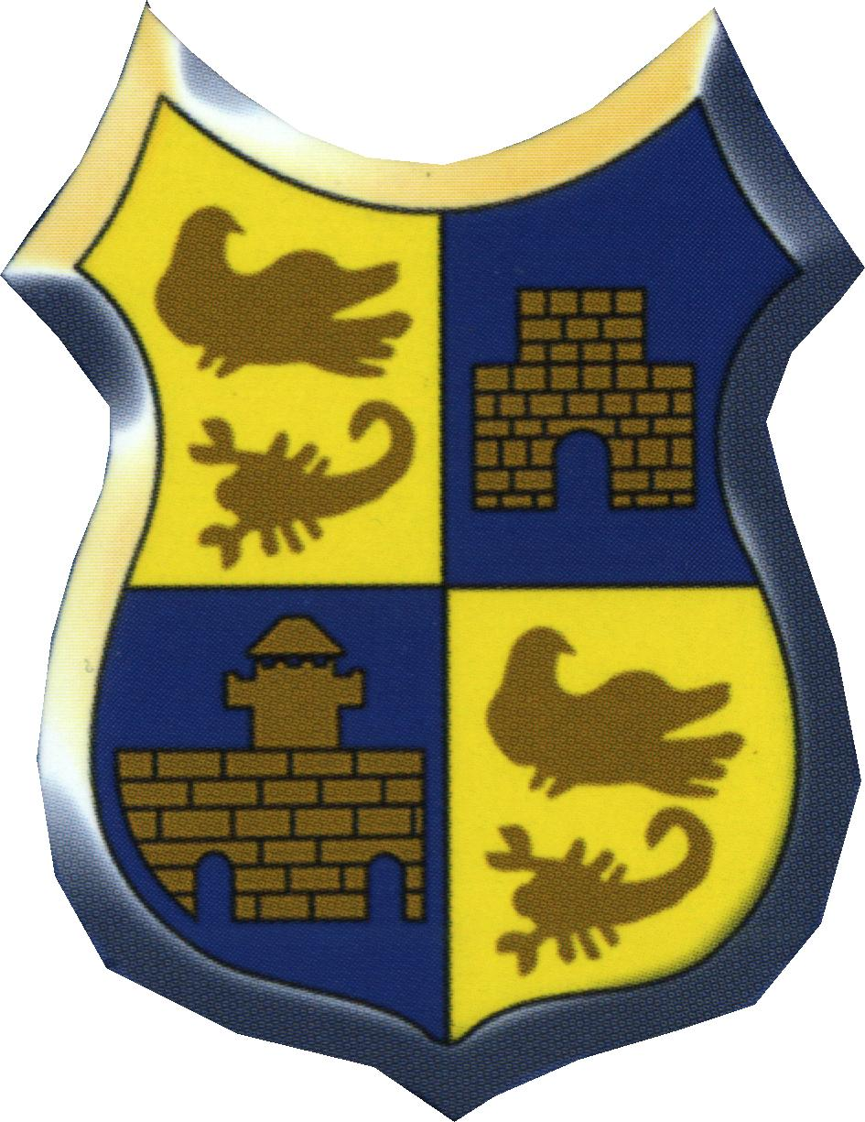 |  | 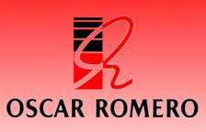
CZECH REPUBLIC - ODRY

Yellow ring

It is quite difficult to describe the “Yellow Ring” in our school. Words like sports and science, science and development, science and physics, science and training, science and use of equipment; science communication and new technology are not used too frequently in our school. We are a primary school for children from the ages of six to sixteen so we just try to give them primary skills in sports activities. Almost all our pupils do sports as their hobby; we do not have proffesional sportsmen. But if a very talented pupil appears we will give him/her an individual study plan and he is still our student. Then his or her proffesional skills are developed in special sports schools in bigger cities like Opava, and Ostrava. And in these kinds of schools science and development and new technology are definitely used more frequently than in our school. Due to development and progress we have got better sport conditions in our school. We can use a new outdoor rubber sport-field that is proper for mostly all team sports like football 4+1, volleyball, basketball, handball, tennis or baseball. We also will have a new sport hall next to our school next year. This new sport facility helps us very much.
And how does science help during lessons? We can use technical equipment that our colleagues twenty years ago could not. For example we can use a digital camera, digital videocamera, personal computers or special watches to measure pulse and heartbeat. When we do athletics or any kind of sports, digital video cameras can help our teachers very much.
We can record students and we can record their own performances and after that we can make an analysis together with them. We can show them what they did well and we can tell them which things or which parts of their performances they should improve. For example, when we have a high jump lesson we can use a digital video video camera to show them an excellent jump step by step. After a recording we can make a detailed analysis of their jumps.
Personal computers help us as well. Results can be printed very quickly and our students can see the results simultaneously, for example, after a tournament. We can find such a huge quantity of useful sports information on different web sites. We, as P.E. teachers of the 21st century, are happy that we can use high technology, science and development even in our school. We are ready to use them and we want to use them, so our work has become more effective and we can better motivate students as well.

HOLLAND – HOORN

Europe and the yellow ring: Sports and Science
One of the main aims of a United Europe is to combine and exchange knowledge. Almost every country in Europe has its own culture. Not only in the artistic, religious, scientific or political field, but also in sports. E.g. the English way of playing football differs from the Italian way. Cricket is one of the sports you will find sooner in Great Britain and other English orientated countries. Ice skating is more related to The Netherlands, Germany and Scandinavia. Skiing has evolved more in the Alps and Scandinavia. The science related to these sports is obviously fragmented. Any one can understand that the development of Carve skis was not Dutch, but the invention of the Clap Skate was.
About 20 years ago this had a very big impact on the development of speed skating.
Within the several cultural differences it is important to understand each other and improve the achievements in sports.
Because it will be impossible to write an article about the development of the science around all kinds of sports in Europe, I will restrict myself in this article to some scientific developments in ice skating in the Netherlands during the last century.

History of speed skating.
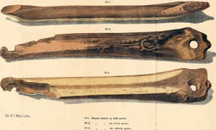
Figure 1: Bone skates
The Dutch word for skate means leg bone and is traced back to schenkel (shank = femur). The oldest pair of skates known date back to about 3000 B.C., found at the bottom of a lake in Switzerland. Probably the first "industrially" made skates were produced by the Scandinavians 1000 A.D. from the leg bones of large animals, holes were bored at each end of the bone and leather straps were used to tie the skates on.
Around the 13th or 14th Century, the Dutch started using wooden platform skates with flat iron bottom runners. The skates were attached to the skater's shoes with leather straps. Poles were used to push the skater forwards. Around 1500, the Dutch added a narrow metal double edged blade so the skater could now push and glide with his feet. This was a major improvement, because the skater had his arms free for more balance or to carry his prey and could develop greater speed.
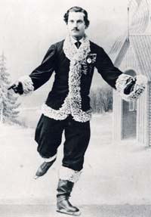
Figure 2: Jackson Haines,
around1865. The founder
of the modern skate.
This was of great value during the Spanish occupation. In 1572 the battle of the IJsselmeer takes place in Amsterdam. The Dutch surprised the more powerful Spaniards by skating the frozen canals for combat.
Halfway the 19th Century the strapless skate with the blades clipped right to the boot is invented in Philadelphia by Jackson Haines. The Norwegian Axel Paulsen was also involved in the development of skates directly attached to the boot. This revolutionizes skating because for the first time skaters can twist, turn, spin, and leap without losing their blades. The double Axel, one of the obligatory jumps of figure skating is still inseparably attached to Axel Paulsen's name.

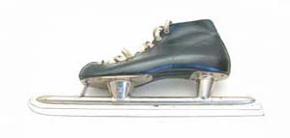
Figure 3:The Steeled
Norwegian Skate
At the same time an other type of skate was developed in Norway. The Dutch called it: the steeled Norwegian skate. The steeled blade was permanently fixed to the shoe.
Because they were very expensive they only became popular halfway the 20th Century. It is most likely that Jaap Eden was the first serious and famous speed skater to use these skates.
January 13th 1892 Jaap won the 1500 and the 5000 meters, the day after he added the 500 meters to his list of victories. That made him the first World Champion. During the 10 000 meter race he fell and couldn't continue the race. In Stockholm, one year later, he broke the 10 km record. The new World record time was 19.12.4. In Hamar he broke the world record time on the 5000 m by half a minute, 8.37.6. This gave some confusion, because one though that the time official had made a mistake reading his stopwatch. This record stood for 20 years.
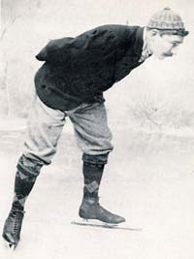
Figure 4: Jaap Eden, 1892.
The first official World Champion
speed skating.
The two most successful Dutch speed skaters were Kees Verkerk (born in 1943) and Ard Schenk (born in 1944).
During his sports career Kees Verkerk broke twelve world records on the 1500 , 5000 and 10 000 meters. He twice became world champion in four disciplines, one time European Champion, four times Dutch champion.
Ard became all-round World Champion four times, three times European Champion and three times Dutch Champion. Ard also broke some psychological barriers. Although it was thought impossible he rode the 1500 meters under the two minutes and the 10000 meters under the 15 minutes.
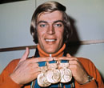
Figure 5: Ard Schenk
The difference between Jaap's and Ard's 10 000 meters were almost 5 minutes! It was long thought impossible to improve this record. Because skating became enormously popular, all kinds of research were done to improve the new World record times.

The clap skate
Speed skating evolved extremely during the second half of the 20th Century. The increase in income, more welfare, caused more attention for ice conditions, the technique of the skates, training methods, clothing, and all other aspects that could increase speed. This kind of interest in the skates was due to more investigations in skate science. All sorts of experiments were done with slimmer and/or longer irons under the skates, with harder steel, other materials like ceramics. Eventually the clap skate was invented. The clap skate is probably the most remarkable innovation in skating. It has a hinge under the ball of the foot. In this way it extends the length of the foot or leg. A longer leg is an advantage to skaters, especially on long distances. Another reason is a better driving power under the foot. Because of the hinge, the foot can stay in contact with the ice longer with every swing of the leg. All World Records were broken with seconds. It is understandable now that long distance skaters must be tall. On the other hand it is an advantage to be short on the short distance. See world records at the end of this article.
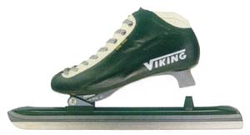
Figure 6: The Clap Skate
Two other ways to improve time records are investigation in costume and ice condition.
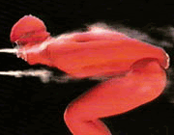
Figure 7: The "Air Flow Suit"
The Costume
Eighty percent of the resistance the skater encounters is caused by air. Scientists of the university of Delft discovered that adding ribbed strokes of cloth to the suit on the head cap and on the legs decreased the air resistance by 5 %. On the 10 000 meters this saves time. The "Air Flow Suit" not only produces better results it also is proof that more research can be done in suits development. These suit are also usable for skiers, marathon runners and so on.

Ice Conditions
The last influence to discuss is that of the ice maker. As explained above 80% of the resistance is due to air. The other 20% is caused by the ice. On the ice surface the first three layers of ice molecules vibrate as if they were real water molecules. The under laying ice molecules tend to be laying still in a matrix. According to computer calculations these top layer ice molecules still act like water molecules in their vibration activity, even 20 to 30 degrees Celsius below zero. Because of the 3 molecule layer the ice resistance is reduced to very low values. Obviously the ice maker has an important influence on the ice condition. He can add chemicals to the ice and regulate the ice temperature. At every geographical height the additions can differ and the ice temperature too.
Temperatures lower than minus 30 ^{O}C makes the ice rough and less suitable for gliding.
World records dated 22-12-2004:
500 M 34,32 Hiroyasu Shimizu Salt Lake City 10.3.2001 JPN
2x500 M 68,96 Hiroyasu Shimizu Salt Lake City 10.3.2001 JPN
1000 M 1.07,18 Gerard van Velde Salt Lake City 16.2.2002 NED
1500 M 1.43,95 Derek Parra Salt Lake City 19.2.2002 USA
3000 M 3.42,75 Gianni Romme Calgary Olympic Oval 11.8.2000 NED
5000 M 6.14,66 Jochem Uytdehaage Salt Lake City 9.2.2002 NED
10000 M 12.58,92 Jochem Uytdehaage Salt Lake City 22.2.2002 NED
Evaluation.
As said before it is important to distribute information on sports science throughout Europe. Millions of people enjoy sports every day. It has to be kept exciting. Improving records is one way of doing so. Science can be a catalyst to improve the joy of sports. Not only for the contestants but also for the public.

HUNGARY – KOSZEG

Science and Technology
Science has been an important part of the curriculum of our 328 year old school for a long time. Chemistry, physics and biology labs were well equipped also during the 19th century. Many tools at the physics lab are still in use.
During the past few decades science education has changed a lot. However, the main structure is unchanged: Chemistry, Physics, Biology and Geography are taught separately. This means, unlike some countries we do not teach a subject “science”. However, as a secondary school, we expect students to have basic knowledge of each subject from the elementary school.
Schools in Hungary have some freedom to set up their own curriculum, but traditions and requirements for entering higher studies demand approximately the same educational program for most high schools.
All students have to have 150 teaching hours of Geography and Chemistry and 225 teaching hours of Physics and Biology (including health education). Our school also offers Honour courses (with more classes) in Chemistry and Biology. Besides these, during their last two years students have to take at least 2 electives to be prepared for the final exam at the end of the high school studies. Sciences need bright brain and willingness to study. That’s why sciences are found to be difficult for most students. To please young people the government unfortunately decided to decrease the number of science classes significantly during the past decade. Many teachers think that this action will negatively affect the role – which has been important so far – of the Hungarians in the future scientific life. However, the number of classes highly depends on the program chosen by the students. As less and less children are born all schools have to “fight” for them, so schools offer a big variety of attractive courses. It is a difficult job to find the right courses to meet the requirements of the educational law, the personal and financial condition of the school and the expectation of students and parents.
At our school there are 5-year-programs (bilingual with working language English; program for talented but socially disadvantaged students; language and computer science program) and 4-year programs (honour chemistry and biology; honour math and computer science; honour language; tourism).
The following table shows the minimal and maximal number of classes a week at the given grade. In this table the electives during the last two school years are printed in Italics.

 | Preparatory year | First grade | Second grade | Third grade | Fourth grade
Biology | 0 / 0 | 0 / 2 | 2 / 5 | 2 / 4 | 2 / 4
Chemistry | 0 / 1 | 2 / 3 | 2 / 3 | 0 / 3 | 0 / 3
Physics | 0 / 1 | 2 / 2 | 2 / 2 | 2 / 4 | 0 / 2
Geography | 0 / 0 | 2 / 2 | 2 / 2 | 0 / 2 | 0 / 2
Computer science | 0 / 4 | 2 / 2 | 0 / 2 | 0 / 2 | 0 / 2

Teachers and their attitude, open mindedness are important. All science teachers of our school have some specialities besides their MS degrees which is a requirement at a high school. Our teachers are open for new ideas; this way also our students are offered a big variety of the modern educational methods. The idea of the project work was taken from international examples. In all subjects a part of the student body works on different kind of projects. However, because of the curriculum, only a part of these projects is carried out during regular classes. There are always a few students who like sciences and a project can be worked out as an extracurricular activity. The number of the students taking part in science project might increase in the future because e.g. in Biology part of the final exam can be a project work, too. The importance of the science projects is also emphasised by many of our famous scientists, and they also help young intelligent students in their project work.
Individuals and group of students also had success in nationwide and also international project work; some of them were initiated by a Comenius project. The “In Vino Sanitas” project grew to an international, CEFIC project, but there were more others which were of great success in nationwide competitions. One of them was the “Kőszeg Walks with Mathematics”, which is an excellent example for teaching mathematics with fun, and getting acquainted with the city meanwhile. It was developed also as a part of our first Comenius project. (Upon this example we think of a new project in the future: math, physics, chemistry questions with different European countries, cities.)
Knowledge and application of new technologies are more and more important in the everyday life. Computers, Internet, e-mail service all are essential for a person of the 21st Century. To improve these skills the Government introduced a program called Sulinet (suli is an informal name of school). The program would like to help teachers to be familiar with computers and they have the possibility to own a computer with the proper software. That’s why in 2003 teachers could buy computers with some financial help (tax reduction in 2004) provided by the government. Also, at schools Internet is free so teachers and students can surf on the Net without being charged.
The school has altogether 3 computer rooms with 12 – 16 computers in each room. In these rooms are held the computer science classes, but they are also open for students in the afternoon to practice, grab information in the Internet, or sometimes unfortunately only to play. Besides these, there are 5 computers at the library, too, so students can use them to prepare for their classes, too.
The school also has a notebook with projector, which can be used in the teaching process. This is not enough, although the physics classroom just could purchase another notebook. Using computers and the Internet is absolutely necessary particularly because of our bilingual program, as there are no books available. This way syllabi can be found in the internal web site, so all students can find the lectures.
At our school all students have some education on computer science, depending on the program they choose. During the regular classes students are not taught to write new computer programs, they rather study how to use computers. Word, Excel, use of the Internet is the main parts of their studies. Most students are familiar with these skills by the end of the first year. Later they study other important skills such as drawing, power point presentation web sites etc. This school-year our great task will be to finish finally our web site.

ITALY - OULX

Phisical Education
The first part of the work deals with the equipment and the gear which are most useful while hiking or doing any other sport activity in the mountains.

Some general points about food are also dealt with, taking into consideration the basic components of nutrition: energy-giving elements (proteins, fats and carbohydrates) and non energy-giving elements (vitamins, mineral salts, micro-elements, water and fibres).
Attention is paid as well to the type of nutrition people need during a mountain hike or any sports activity.
One chapter is dedicated to alimentary integrators and their classification: water, glucose, fructose (simple types of sugar), glucose polymeric carbohydrates (malt dextrines), mineral salts, vitamins, ramified amino acids.
While integrators simply help a healthy and fit organism to reach the best condition to endure a big effort, nutritional ergogenic aids under some particular circumstances help to improve performance in some people.
The chapter on nutritional ergogenic substances having no pharmacological action (the aim of which is to improve the physical power or endurance by increasing the metabolic processes involved in the production of energy during training) deals with: ramified amino acids, creatine, caffeine, guaranà and kola nuts, ginseng, ribose, alkaline salts, carnicine, arginine and ornithine, spirulina.
One chapter is dedicated to doping. It is an illegal action in sport because it gives an illegally acquired advantage with no respect for the rules of sport.
Besides being a sports crime, doping is also a criminal offence according to law 376 of 14 December 2000, with the possibility of administrative and penal sanctions.

The second part deals with physiopathology and mountain environment.
Mountain environment may affect man’s health in three main ways: altitude, irradiation and temperature.
Traumatology: the causes of accidents play an important role in the nature and the evolution of the injuries. Other etiological elements may complicate the problems: fatigue, cold temperature, bad weather conditions (wind, snow, ice, fog), altitude (the fact of being/not being used to it) may rapidly worsen the evolution of even the simplest lesions.
Furthermore the intervention of specific external factors can make the injury even more serious: a forest fire, an avalanche, the fall into a crevasse increase the problems caused by shock, fractures or multiple contusions.
In particular this part deals with: contusions, sprains, muscular lacerations, fractures, dislocations, haemorrhages, electrocutions, burns, snake bites and insect stings.

The last part of the work deals with first aid conducts and techniques with particular reference to the mountain environment.
In case of suffocation (avalanches and landslides) the possibilities of survival depend on the duration of the state of hypoxia, therefore resuscitation must begin as soon as possible.
To evaluate the need for intervention the following elements must be taken into consideration:
A=Airway: opening of respiratory airways. The presence of an obstruction of the respiratory tract quickly causes respiratory failure.
B=Breathing: artificial respiration. Respiratory failure quickly causes heart failure.
C=Circulation: heart massage. When the heart stops beating there is no blood flow to the brain, which leads to alterations first (after 4-6 minutes) and then to the death of the brain cells (after 10 minutes).

In an appendix to the work a scale of danger of the Probability of avalanche issued by C.N.S.A.S. and a list of safety rules for hikers can be found.

Keep in touch
For periods of average duration some students of Des Ambrois can attend one of the schools twinned with ours in compliance with agreement protocols, allowing cultural exchanges, which are by now settled habits.
Several students are engaged in competitive sports or sports activities tightly bound up with our area, above all Alpine skiing. The Project "School-Sports" allows them to reconcile their competitive engagements with school ones, thanks to an individualized teaching methodology and to flexible schedules making up periods of absence from classes, sometimes even very long.
Particular attention is also paid to students needing remedial work: they are granted individualized extra lessons to support them out of the curricular schedule.
Out of consideration for the particular needs of these students, in order to meet their requirements, to encourage experiences both at school and in sports and to give them the chance to get acquainted with other cultures, a group of teachers has worked to give rise to a new possible relationship between teachers and students.
As a result students can avail themselves of on-line lessons they can enjoy whenever and wherever they like, at least wherever they can surf the net.
The experiences in such a field sense have been mainly of two types:
1)Some lessons in different subjects regarding specific parts of the teaching plan, equipped with exercises and working cards, that could be used in a contemplated way.
2)The on-line register made up of weekly files in which teachers supply their students with the topics they dealt with and the homework they assigned, but also to remind them of the forthcoming deadlines (tests, homework, etc.) and to attach documents such as a copy of the latest test submitted to the class.
In such a way each teacher can make a choice of what he considers to be more useful for the students absent from school, directly reporting with each of them, with no intermediaries and with no need of other means.
Why is this work thought to be useful, if the contents can be found on the text book in use, and if information can be got from classmates?
For someone who doesn't know anything about a certain topic, it is very difficult to make choises of content, to look for the basic concepts autonomously and to be able to single them out, if he/she does not have the competences to do it and if he/she has only a little time to work on that. It is therefore a practical need.
Moreover, staying a long time away from the classrooms can make students lose touch with the school reality and make them feel as if they were a bit “cut out”. It is a psychological need, as well.
Therefore, it is really important to offer an on-line guide, taht is a contact with the school, even if through a computer.
There is not just a way to reach the target and each student has to personalize his own formative experience studying in depth and working with his/her teachers to develop the abilities to be achieved at the end of the course of studies.

SPAIN – CIUTADELLA DE MINORCA

Evaluation and improvement of the physical state
The objective of this work is to get acquainted with the motility and physical properties of the human body, to evaluate and value them.
This work is developed individually, so that each student can see, in an objective way, his/her own shortages in the different items evaluated. In this way each one can choose the physical activity more appropriated to improve his/her physical state, improving at the same time health and the quality of life.
Another objective is that the students get acquainted with different systems of training the motility and physical properties, so that they will be able to prepare a programme of training sessions in order to improve their individual state.
This minimum autonomy, when preparing a programme of improvement of the physical state adequate to the individual needs, guarantees that the physical and sportive work done afterwards will be inside health parameters.

These are the steps followed:
- To take a battery of physical tests following the execution protocols indicated in the notes given to the students.
- The results of each test are registered.
- All the results are evaluated according to the scale mentioned in the notes. The scale is different in each test and age and sex are also taken into account.
- A graphic is made. The values, in the vertical line, and the tests made, in the horizontal line, are grouped according to the motility and physical properties they refer to.
- With the individual graphics made, it will be possible to evaluate objectively each one’s properties. To see where we are best prepared and where our shortages are. It will also be possible to detect the reason for the shortages and to correct them.
- A training programme, adequate to each individual, the environment and the space and material possibilities of the school will be devised. A minimum of 10 sessions will have to be held during the Physical Education classes.
- At the end we’ll make a personal evaluation of the activity.

The tests taken are:
Endurance : Ruffier test
Burpee test
Test of a kilometre
Cooper test
Course navette test
Speed 50 metres test
40 metres thrown away test
Plate tapping test
Strength Arm flexion in bars test
Jumping with feet together test, horizontal
Jumping test, vertical
Throwing a medicinal ball test
Abdominal test, 30 minutes
Abdominal test 1 minute
Flexibility Trunk flexion test
Trunk flexion, front
Dube bridge test
Balance Scales test
Balance bars test
Co-ordination Throwing to the bulls-eye test
Slalom with a ball test
Agility Obstacle race test
10 x 5 metres test
Sportive performance test
Global Global test, technical circuit.

Science and communication

We decided to understand “science and communication” as the impact of the new technologies in education and how they have affected the traditional teaching methods. We also wanted to compare the equipment and the use we make of it at our different schools.
With reference to Josep Mª Quadrado at Ciutadella we have made a survey of the equipment and have asked the different departments how much they use it.
We are 460 students and 45 teachers.

The equipment
First of all we can’t consider our school to be representative of a standard Secondary Education School in our community. Ours is a pilot school and ever since 1985 interested in the new technologies with teacher training courses and the acquisition of computers, video players, video cameras and overhead projectors.
At present there are some 60 computers at the school, all of them have ASL connection to Internet. There are two classrooms with computers (one with 10 and the other with 11), there are also computers in the teachers room (4), in the library (1), in the Technology work-shop (5) and one in each of the different departments.
There are TV sets and video players in some classrooms and there are two sets on wheels that can go from one classroom to another.
There is also an audio-visual classroom, they have 6 video cameras, a table for mounting and a mixing sound equipment.
There are 2 teachers in charge of the material.
Most students have computers at home, even if not all of them are connected to the web. For the ones who aren’t, the school computers can be used on Wednesday afternoons.

Its use
The Catalan department uses programmes to teach the language to immigrants (the groups are very reduced).
This department offers an optional subject called “communication processes”, in it students learn to use the scanner, to search information and to prepare power point presentations. After that they follow a complete communication process; in the case of the 1st year students their final produce is a story with illustrations and sound, the 2nd years produce a comic; both are put into the web page of the school
The Latin department, with very few students in the post-compulsory education, has a web page designed by the teacher (“Conspectus”) which is used as a textbook. All the students are supposed to have their own computer.
The social sciences department offers “history of art” as an optional subject to the last year students, they use Internet to find information and to “visit” museums and works of art. Younger students (14 years) of social sciences also take part in European competitions through Internet.

The maths department uses the overhead projector to teach functions. The students from the optional subject “maths workshop” go to the computer room once a month and work with maths programmes.
The subject “computer studies” belongs to this department, students work in the computer room getting familiar with different programmes. Depending on their age they learn to use Excel, Words, Access, to navigate through Internet and the operative system of Windows.
The foreign languages department (French and English) works mainly with CDs and sometimes videos; there is an optional subject called “news magazine” where students use Internet to find information and Word to produce their own magazine.
The technology department uses computers at 4th level (15 years) to automate machines devised previously. They also use an assisted design programme (AutoCAD)
This department offers an optional subject called Pneumatics and “Neumosym”, a programme of simulation, is used in the classes.
The sciences department (biology, physics, natural sciences and chemistry) uses mainly the lab; the use of videos and projectors is sporadic.
The optional subject “Astronomy” uses computer programmes in its classes, one has been designed by the teacher himself.
The art department offers an optional subject, “Image and Expression”, to the oldest students, they use video cameras, the mixing table and the mounting table.
In another optional subject called “Audiovisual communication” the 16 years old students also use video cameras and produce videos with sound.

Conclusion
It seems that the new technologies are mostly used in optional subjects (which usually have reduced groups) and with the older students. It also seems that the traditional teaching method is still prevalent with younger students and in the compulsory subjects.
The classrooms with computers are mainly used in “computer studies”, where students learn to use them, and “communication processes”. Apart from that it is necessary to reserve an hour to use the computer rooms, a list of occupation of the computer classrooms is at the teachers room.
The fact of having to reserve the room beforehand is seen as negative; many teachers complain of difficulty in the access to computers. The same feeling applies to the use of the projectors or video players. Some feel that organisation would improve if there where specific classrooms for biology, English… with all the material there. At the moment it is the teacher who has to carry, or move, the material from class to class.
Other reasons given for the scarce use of the new technologies are: the undisciplined and large groups of younger students and the length of the programmes.
All the teachers use computers and Internet to prepare their classes, but the use of the new technologies in the classroom is not too frequent, probably we don’t take advantage of the material we have.

G.R.Y.B.B. – The Black Ring

Languages
Cultural Exchanges
Sport

 | LP Alpes et Durance  Embrun |  |  |  | Hoorn
IISS Des Ambrois
Oulx

CZECH REPUBLIC – ODRY

BLACK RING - Sport and culture

What is sport? There are a thousand definitions around the world. I remember very clearly a definition that sport is a social phenomenon. A lot of people think that sport is only an activity that has special rules and which takes place in outdoor or indoor sport fields. But that’s not really true. That is only one attribute of sports. We mustn’t forget sport as an event during which people can meet each other. It is an event when people discover different cultures. People can familiarize themselves with habits, traditions, international cuisine or everyday common lives of different countries to where they travel. Then they can compare, bring their rich experience back home and use them for human well fare. And this is a very important role of the sport as well.
A typical example of the biggest sport events is the Olympic games. Every two years the summer and winter Olympic games are organized around the world. It is not only the sports even of the year but also a very important cultural event. We could watch an opening and closing ceremony that is a colossal show and marvelous parade full of cultural elements not only from the history of this or that country. I believe that the Olympic games are the biggest connection between sports and culture in the world nowadays. And what about sports and culture in our school? We started with a school partnership many years ago. We had one partner school from Germany in the town called Heidelberg. Now we have got several partnerships. We cooperate with partner schools from Kuznia, Poland. We have got another partner school in Liptovsky Mikulas, Slovakia. The third partner school is in nearby Bilovec which is only 20 kilometers from our school. We organize a lot of exchanges with the Polish school.
There aren’t only sports meeting twice a year but there is also a cultural meetings, like for example, painting competitions in which our students take part as well. We have got a good experience with school class trips. The Polish classes arrived in Odry to spend a couple of days here to discover our school, town and surroundings. Our students, for example, go to Liptovsky Mikulas, Slovakia every year not only for sports but also to obtain a cultural experience with this beautiful Slovak region. We think that sports meetings and competitions are cultural meetings as well as cultural events. We organize Olympic games in our town every year. This competition lasts for days and it’s important sports and cultural event for all students from all schools in our small town.
At the end of the school year we organize a cultural performance called school academy. One of the important parts of this event is sport where our students can show their sports skills. Every year before Christmas our school enters tournaments in our gym. We try to put together Christmas and sports to put sports and the most favourite holiday among our students together. These tournaments are very popular and lots of our students take part in them.
Multicultural education is one of the important parts in a new school general educational framework. For us, as teachers, this is an opportunity to explain to our students how important it is knowing about the different cultures and how important it is to be a part of cultural exchanges. Nowadays, the best opportunity for our school is our partnership with other schools in our project G.R.Y.B.B. rings for education. This international project as all parts of the educational programme SOCRATES-COMENIUS helps us to bring an European dimension into our school. Our cooperation with partners from Spain, Italy, Hungary, Holland, and France helps us to educate our students and to teach them to think in a European and global relations. If our students want they can become real European citizens.
All our teachers and all of our students believe that sports and culture are bonded together and they are an important part of our school curriculum.

HOLLAND – HOORN

Europe and the Black Ring

Europe fascinates me. There is a lot of history and diversity in such a relatively small place. After such a long and bloody history, I consider myself lucky to live in a time when Europe to me means traveling, visiting exciting and beautiful places ( Menorca, Odry, Olomouc, Prague, Paris, Rome etc. ), meeting interesting people ( all my friends of the different delegations in this project ), experiencing different cultures and customs etc.
Because of these experiences and the unison of Europe I can say that part of my identity is European.
The original idea of the European Union – solidarity – was great, but we are in a critical phase at the moment. I think we could make it right only if we start working together. I think we will not attain the ideals of the EU as long as it is only composed of rich countries. Therefore it is very important that the countries in the East of Europe became EU members last year.
But it is also important that we found the right way to live together with people on the other side of the Mediterranean, such as Morocco, Turkey etc. We are faced with a different religion and other cultural usages in this way.
The EU has become a lot like a democratic state, it guarantees its citizens their basic freedom of consciousness, freedom of thought and feeling, freedom of opinion, freedom of preference and freedom of religion. However, democracy merely taken as majority rule is not an ideal way of governing. That’s why countries try to develop “liberal democracy”; also guaranteeing minorities’ rights.
In our country it was therefore a terrible event that the film maker and columnist Theo van Gogh was assassinated on 2 November 2004.This murder has made a big impression and a big wound in Dutch society. The social climate and the possibilities for an open and fair debate, without fear, sustain damage again like the time that Pim Fortuijn was assassinated. The freedom of expressing opinions and the possibilities for an open dialogue in the Netherlands must be protected against violence and intimidation.
There is a lot of discussion and debate, at home, at school and in the media about these problems. A wide understanding seems to arise that first of all the extremist, from whatever denomination at all, must be tackled.
At this moment there are a lot of positive initiatives in the Netherlands ;
- Promotion of the dialogue between the different religions, denominations and cultures.
- No fortification of the clashes between “us “ and “them”
- Shading the freedom of expressing opinions
- Improving the image of the Muslims and the not-Muslims
- A red bracelet with the words “Bracelet against Violence” or a orange bracelet with the words “Respect2All”.
- A letter from the bishops of the Netherlands about respect and peace
- Different cultural meetings and music festivals in the Hague, Amsterdam and Rotterdam.
- A lot of discussions on TV and in the other media between people of the Netherlands and people of the different countries who live in the Netherlands.

Perhaps we must realize that Migration has been with us since the days of Palaeolithic man, and is a natural response to economic difficulty. Of the six billion people in the world, five billion live in poor countries. It will be in those countries that the upcoming population explosion will hit hardest.
One thing that globalisation has done is to break down information barriers. Poor people now know far more about what life is like in rich countries and this has intensified their desire to move. With anti-immigrant sentiments running high, European governments are now trying to stop immigration. The only way in is ‘the refugee way “: This forces migrants to pose as refugees, thus undermining the tolerance of Europeans for those who genuinely need protection.
Certainly, there are legitimate arguments in favour of migration being regulated. Migrants make demands at schools, hospitals and housing. It is also important that governments respond to anxieties among the native population. That does not mean appeasing racist or xenophobic sentiments but explaining the facts of economic life: populations in the West are ageing as birth-rates fall and they will need more able-bodied workers from abroad to keep them in their old age. (Reference: Global migrations , by Harry van den Bouwhuijsen in “ It’s a small world” , Part 2,Europees Platform )
At last : In the Netherlands a commission of the Dutch government has produced a study about values. In this report it was declared that there is a understanding in Europe about six values, that each is based on one of the religions or views of life:
- Faith in the future ( Jewish thinking)
- Equality of everyone (Christian thinking )
- Rationality ( Greek/scientific thinking )
- Universality (Christian thinking )
- Personal freedom / individuality ( Christian, humanistic thinking )
- Justice (Jewish thinking )

HUNGARY – KOSZEG

Black Ring – Sport and Intercultural Activities
„Citius, Altius, Fortius”

Living beings have been competing, many times even fighting with each other for many millennia. Animals have been fighting for the best territories, more food and also, for the most attractive mates. People inherited this behavior. The desire of people to be compared to others led to competition where participants could prove their strength, power, skills. Not any more the food was at stake, but somehow these competitions still reflected their origin: those who achieved a good result in the competitions would more likely survive the fight against the enemies and for their strength and good physical conditions were admired by others.
The most important and traditional sport competition is the Olympic game. According to the records it was organized first time in 776 BC, and it was organized every 4th year for the upcoming 1000 years when Roman emperor Theodosius banned it. At the end of the 19th century when sport was getting more and more organized so it was possible to revive these famous sport games.
Pierre de Coubertin, the father of the modern Olympic Games did believe that sport and Olympic Games serve the peace of the nations in the world. To emphasize this he introduced the symbol of the five interlaced rings representing the idea that the Olympics are universal, bring athletes from the entire world together.
The flag, the flame and the doves (in cold weather white balloons), the text of the anthem and the oath all radiate the strong belief in the honest, peaceful, respectful competition based on the ancient practice.
All students in Hungary are familiar with the above described facts; they are parts of the general education. Although during PE classes are mostly training, practical work, a part of the classes deal with theoretical questions such as sport and health, famous sportsmen, doping, sport and personal development, sport and culture.
During the ancient Olympic Games the use of guns was prohibited, battles were suspended. Despite of these, nowadays sport and history or politics are sometimes unfortunately not independent. We should think about the cancelled three Olympic Games because of World War I and II, about the partial Olympic game during the Cold War.

However, sport can also help to commemorate important historical events. In Kőszeg such a traditional event is the History Race held on the first or second weekend of September. People from all over Hungary, and also from outside of the country can compete in more categories. The short distance is 1532 m, to remember the successful siege against the Turkish army in 1532. The heroic fight of the Kőszeg offenders protected Vienna and very likely other western territories against the Turkish occupation.
Ancient Olympic Games were both religious and sport events. Nowadays sport events are also cultural events. Meeting so many different people allows them to study each other’s customs, habits, language. Comparing the mentality of a nation and the popular, traditional sports we quickly will find the similarities. The opening and closing ceremonies give the opportunity the organizing nation to introduce her characteristic clothes, dances, songs etc. Even the outsiders can improve their cultural knowledge through these events.
Sport has changed a lot during the past decades. Participants have to show a better and better performance. To be able to meet the requirements teams found different methods. Many of the teams force their sportsmen – or even the horses in a race – to use illegal chemicals. The other method is hiring foreign sportsmen to improve the performance of the team. Sometimes this is successful, but many times right because of the different cultural background even the best foreign player fails.
Hopefully these experiences all will lead people back to the honest, fair sport, where not the unreal continuous improvement is the goal, regardless the consequences, such as permanent health damage or even death, and the disrespect of the sport.

ITALY – OULX

Inhabiting the world, understanding and living responsably.

The Des Ambrois school is close to the French border, situated at the top of an alpine valley. Its students come from a wide and varied area, some undertake long journeys, to reach this quiet school. A teacher, who has greatly contributed to the identity of the school, said that buses and trains come here and it is from here that they leave again to travel the world. Stating that the Des Ambrois is a “frontier” and not a “border” school we make reference to a long-standing tradition of studying and to the definitions that Piero Zanini helped to spread with his book1. From such a perspective the Des Ambrois is close to the border but it’s not limited by this, on the contrary, the fact that it is close to the border opens new possibilities to move towards the unknown, to learn, and to accept differences and new challenges.

Inhabiting the world is a title that covers many intercultural projects that our school offers. Learning to understand, to encounter and confront the unknown is an important step towards surviving in a world outside our valley, our region and our country.
Our school has always been involved in exchange visits, with students from all over the world, from both developed and underdeveloped contries. Exchange visits are particularly educative because taking part in every-day activities (eating,sleeping etc.) discloses a profound comprehension of what unites us all.

In our school, cultural exchange is highly valued and includes many different activities. The school is made up of several different sites and studies (middle school and high school: classics, scientific, linguistic, european, tourism and grafic design). There is a wide internal variety which encourages sensibility, objectivity and practicality. The students learn to accept and appreciate their own culture and to see things from another point of view.

Looking back on some of the projects undertaken over the last few years shows us much. “Over the sea, over the sand” involved discussing with Cameroon schools about life, illness, death (from aids to corruption). “Education of the global citizen” is an attempt to discuss with Chilean, Cameroonian, Dutch and Austrian students about rights and ways of life. GRYBB draws attention to the olympic event, especially to the social and cultural aspects of this meeting. Czechs, French, Dutch, Hungarians, Italians and Spanish are the protagonists of this discussion. “Youth of Europe” is a project that lasts four years and is an attempt to work out the destiny of Europe starting from the horrors of Bosnia. “Mediterranean: the border of class culture” is a moment of thought about classicism, about Mediterranean, about Rights and of borders. It involves Italians, Spanish and Turks. “Bolivian project” is an exchange programme in which hospitality is fundamental because the latin-american delegation can provide lessons in spanish and latin-american literature. “Thirst for Justice” involves schools from different African countries: Nigeria, Burkina Faso, Mali, Sarawi. Cultural demonstrations and fund raising underline the fact that there is no peace without justice.

SPAIN – CIUTADELLA DE MENORCA

Diversity at our school
During the last years Menorca has become the destination of quite a number of immigrants from all over the world. Nowadays from a total population of about 80.000 people there are some 5.200 immigrants from different countries. The children of those immigrants, enrolled at the schools of the island, have specific educational needs, which is our challenge to meet.

The number of foreign students at our school is 28 (only a 5.89% of the total while they represent the 7.83% at other schools in Ciutadella and the 10.08% in Menorca). This academic year there are students with 13 different nationalities, which are distributed as follows:
371 Spanish; 11 from Ecuador; 4 from Uruguay; 3 from Argentina and 3 from the United Kingdom; 2 from Colombia and 2 from the Netherlands; and only 1 from the following countries Dominican Republic, Cuba, Portugal, Russia, Mexico and Peru.
(In the schools of the island there are pupils and students from 44 different countries, they come from Ecuador in the first place, from the United Kingdom in the second and from Morocco in the third).

At our school there is a special programme called PALIC (Linguistic and Cultural Attention Programme) which takes care of those students that arrive without knowing the official languages (Catalan and Spanish). As Catalan is the language of the Community and the language in which most learning is done, the main aim of the programme is to teach the newcomers to understand and to speak Catalan so that they can follow the classes. The programme is flexible and the students come and go according to their progress. Each student has an individual timetable in which are specified the PALIC hours and the hours with the class-group.
In addition to the PALIC Programme there exists a document called the Linguistic Project of the School in which the language to be used is specified; this document gives special attention to the use of Catalan, a language in process of recuperating the area in use.
According to research 88.5% of our students use Catalan in their daily life and 10.5% Spanish. The rest use different languages.

Considering the numbers we conclude that diversity at our school is still moderate but it will very likely grow in the future so it is necessary to give it a meaning both educational and pedagogical. The objective is to show, and teach, that linguistic and cultural differences are a challenge and should be considered as enriching experiences, which help us understand each other.

To emphasise this objective the Diversity Day was celebrated last year. The aims were two, on the one hand to make students aware of the diversity existing at the school, and on the other to help them adopt a positive attitude towards it.
Every department made a special programme for a particular Friday; the timetable was the same but in every class the subject was treated from the point of view of the diversity (languages, history and traditions, festivities and celebrations, music, stories and literature, climate, food, games and sports, plants, landscapes, animals…)
In addition, a group of students and teachers prepared an exhibition, which was set at the entrance of the school. The exhibition included
- World maps of linguistic diversity, of biological diversity, and of nations
- Extracts from the Universal Declaration of Linguistic Rights and from the Educational and Linguistic Project of our school.
- Images of ethnic diversity (people, games, food)
- Information about the “Forum de les Cultures” which took place in Barcelona last year.
- Proverbs from different parts of the world.
- Data about immigration in Menorca (both historical and recent)
- A panel covered with cuttings taken from newspapers and magazines, all of them had one thing in common: they dealt with immigration.

The objective of the day was to think about diversity and to realise that without diversity
- It is impossible to understand humanity.
- That diversity is a treasure to be preserved and, furthermore that diversity is becoming more and more present in our island, in our city and in our school so we have to know about it, understand it and love it.

Francesc Florit Nin, from the Linguistic Normalisation Committee, has done this research.

