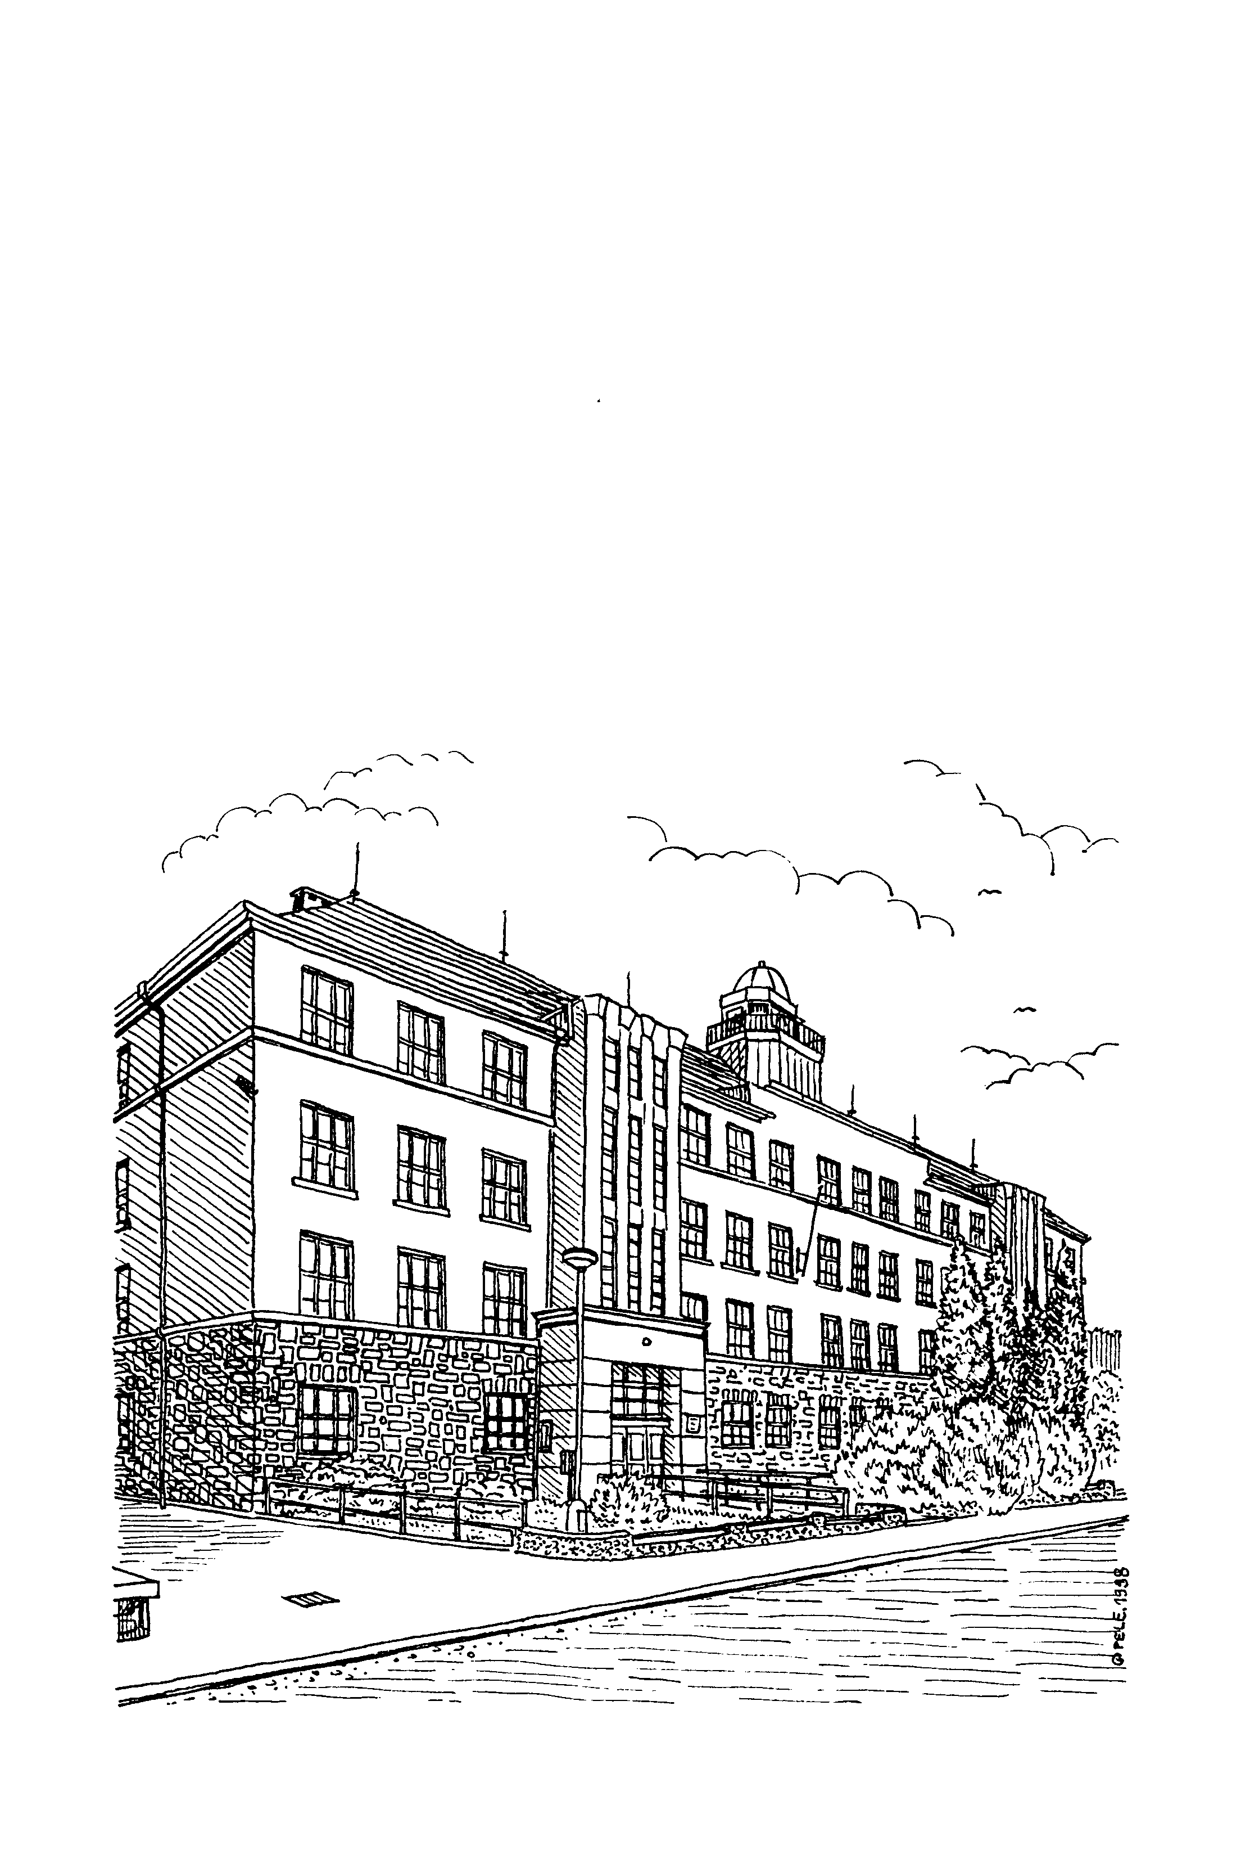
Základní škola ODRY

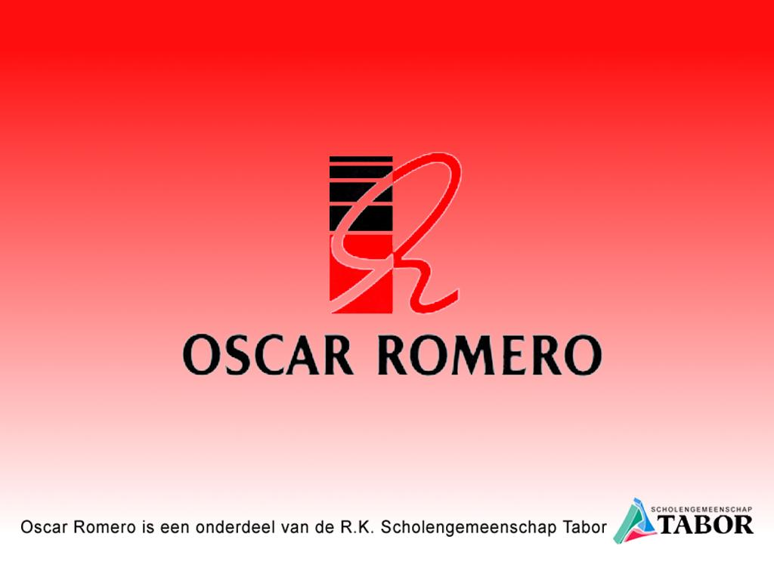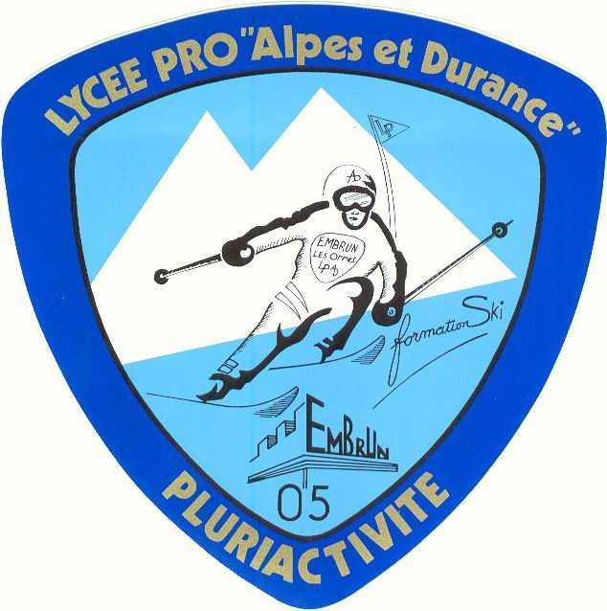G.R.Y.B.B. – project meeting, Hoorn, NL
7-11 november 2005
A conference with the partners of a Comenius-1 school development project:
Hungary, Czech Republic, Spain ( Minorca), France, Italy, The Netherlands and TOROC ( Torino Olympic Comity )

Provisional Program
s.g. Tabor, loc Oscar Romero, Hoorn, The Netherlands
Bousteen 1
1625 PD Hoorn
Tel. 003129285685 Fax. 0031229285688
Contact : T.M. de Groen
Home tel. (after 20.00 p.m.): tel 0031228543081 and mob.: tel . 0031620279587

Day | Activity | Responsible | Notices
Monday  7 November  20.00 p.m | Travel; Arrival Hoorn  Host families  Hotel  Opening: diner for teachers in school | Students:  T.M. de Groen  Teachers:  A.Lommerse  Catering Oscar Romero  Management, N. van Beurden | Address teachers partner schools:  BMG Hotel Hoorn ***  Lepelaar 1  1628CZ Hoorn  Tel: 0031229249844  Fax: 0031229249540  Email: hoorn@bmghotelgroep.nl  Teacher room Oscar Romero
Tuesday  8 November  8.00 a.m.  8.30 a.m.  8.55 a.m.  9.20 a.m.  9.20 a.m.  10.00 -12.30 p.m.  13.15 – 14.00 p.m.  14.15 – 14.45 p.m.  14.45 – 17.30 p.m.  14.45 – 17.00 p.m.  18.00 – 23.00 p.m. | Coffee, tea  Welcome, Opening  Energizer  Guiding tour teachers  Guiding tour students  Dutch Sports  International meal  Olympic Spirit  Students route Hoorn  ( VOC )  “Teachers Talk” with colleagues ( same subject )  Diner by colleagues at home | N. van Beurden  T.M. de Groen  S. Franssen  Students Oscar Romero  N.van Beurden, A.Lommerse  C.Swan  Students,  S. Franssen,  T.M. de Groen,  D. Geeresteijn  C. Geeresteijn  A. Lommerse  C. Swan  P. de Marchis  Students,  K. Olijhoek  M. van Tilburg  A. Knop  Colleagues families | Teacher room Oscar Romero  New Aula Oscar Romero  New Aula Oscar Romero  Oscar Romero  Oscar Romero  Ados hall, Linge weg, Hoorn  New Aula Oscar Romero a  Mandela hall  Hoorn  New Aula and teachers working rooms  -. Sharing ideas,  -. Looking cooperation future  -. Possibilities to exchange  Hoorn and surroundings
Wednesday  9 November  8.30 a.m.  9.00- 12.00 p.m.  12.30 – 13.30 p.m.  14.00 - 16.00 p.m.  16.30- 18.00 p.m.  19.00- 23.00 p.m. | Energizer  Para-Olympic day  Lunch in the city hall??  presentation students:  Para- Olympic sports in the partner countries  Teachersmeeting  Teachers: Sight seeing Hoorn, diner Ridderinkhof | Students Oscar Romero,  T.M. de Groen  T.M. de Groen  Students all countries  P.de Marchis  N. van Beurden | P.E. rooms Oscar Romero  City-council/mayor  Mandela hall Oscar Romero  10 (Max. 15 min. !!!) min. every country !  Mandela-hall Oscar Romero  Restaurant in Hoorn
Thursday  10 November  8.00 p.m.  8.30 - 17.30 p.m.  17.30 – 20.00 p.m.  20.00 - 21.00 p.m.  21.00 – 21.45 p.m.  22.00 – 24.00 p.m.  24.00 uur | Energizer  Variable Program  Bus …..Site seeing  Students home  Teachers Hotel  Film festival  “Oscars”  O.R. show !!  Dans party  The end | Students Oscar Romero  A.Lommerse  C.Swan  S.Franssen  A. Lommerse  N. van Beurden  T.M. de Groen,  E van der Fluit ,  C. Swan  T.M. de Groen,  Students Oscar Romero | New Aula Oscar Romero  - Ijmuiden  -.Dunes, Sea-side  -.Amsterdam  Refreshment at home, hotel!!!  Mandela-hall Oscar Romero  Oscars for the best film,…… !  Theme: “preconceptions“  Invited are: Dutch parents, all students, teachers, ea.  New Aula Oscar Romero  New Aula Oscar Romero  New Aula Oscar Romero
Friday  11 November | Travel : Departure  Diplomas/Certificates, | T.M. de Groen

